**Obtaining OAuth Keys**

<https://www.npmjs.com/package/satellizer>



* Visit [Google Cloud Console](https://cloud.google.com/console/project) ( <https://console.developers.google.com/project> )
* Click **CREATE PROJECT** button
* Enter *Project Name*, then click **CREATE**
* Then select *APIs & auth* from the sidebar and click on *Credentials* tab
* Click **CREATE NEW CLIENT ID** button
  + **Application Type**: Web Application
  + **Authorized Javascript origins**: [*http://localhost:3000*](http://localhost:3000/)
  + **Authorized redirect URI**: [*http://localhost:3000*](http://localhost:3000/)*/history*

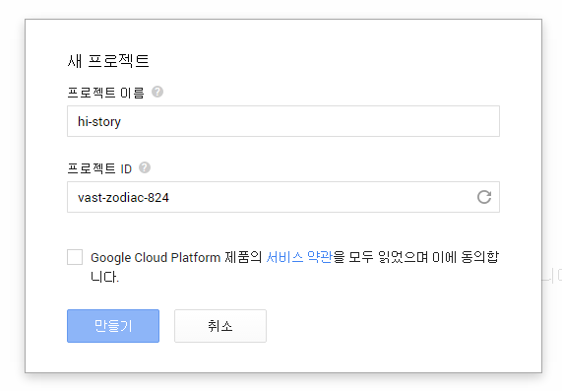

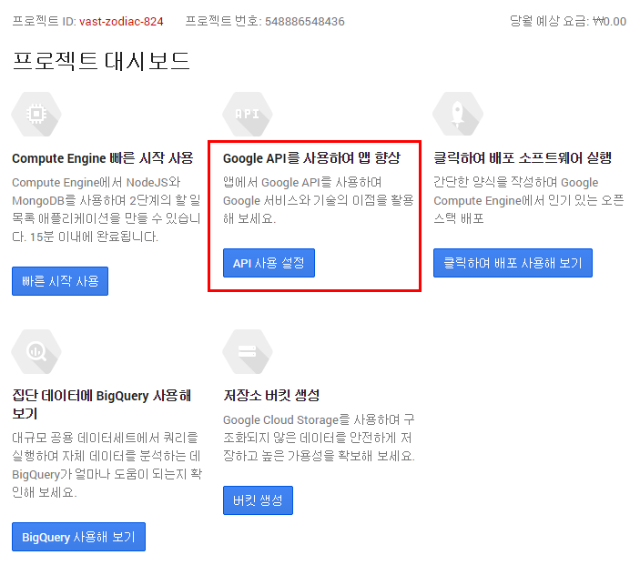

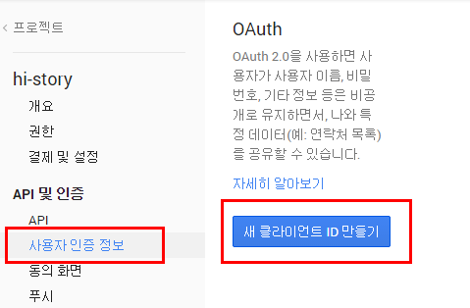

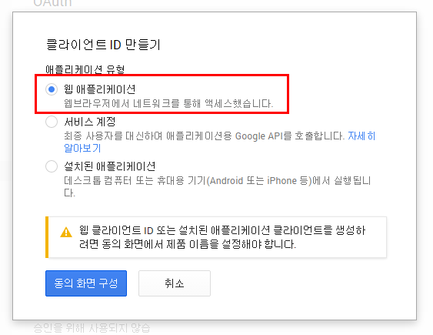

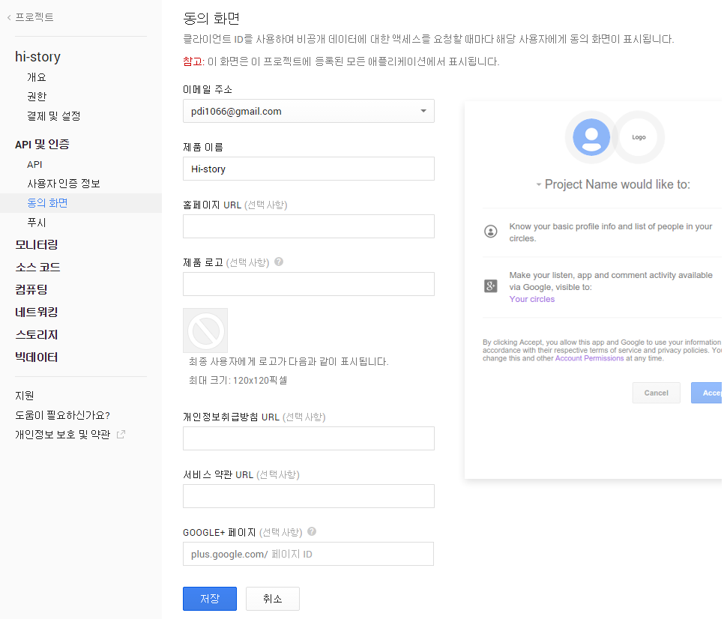

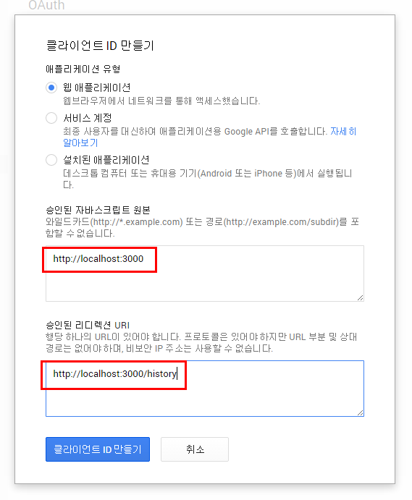

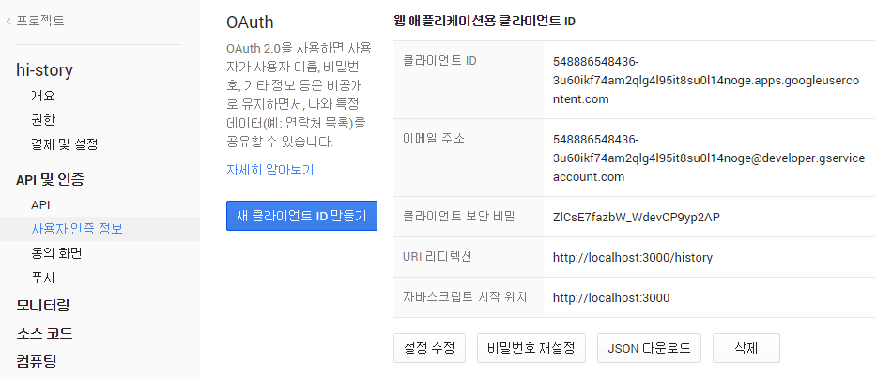

App 인증 출력 성공 화면

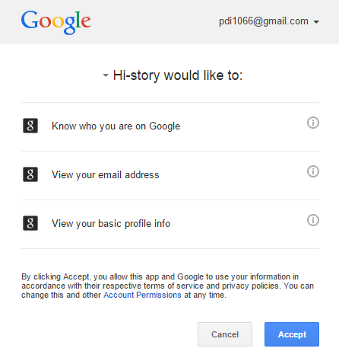



* Visit [Facebook Developers](https://developers.facebook.com/) ( <https://developers.facebook.com/> )
* Click **Apps > Create a New App** in the navigation bar
* Enter *Display Name*, then choose a category, then click **Create app**
* Click on *Settings* on the sidebar, then click **+ Add Platform**
* Select **Website**
* Enter [*http://localhost:3000*](http://localhost:3000/) for *Site URL*

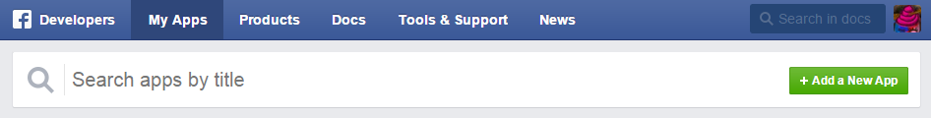

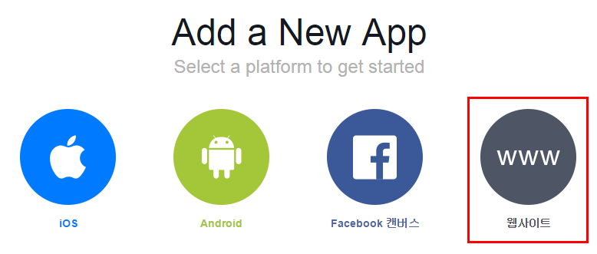

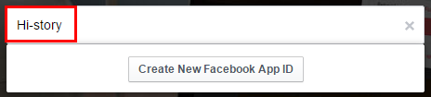

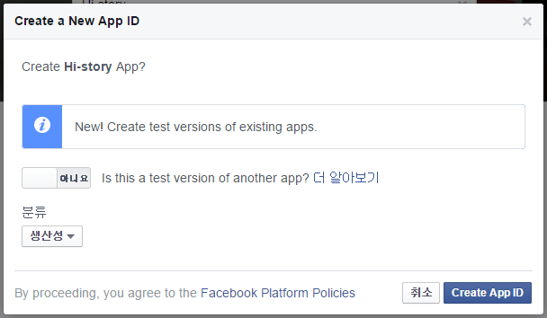

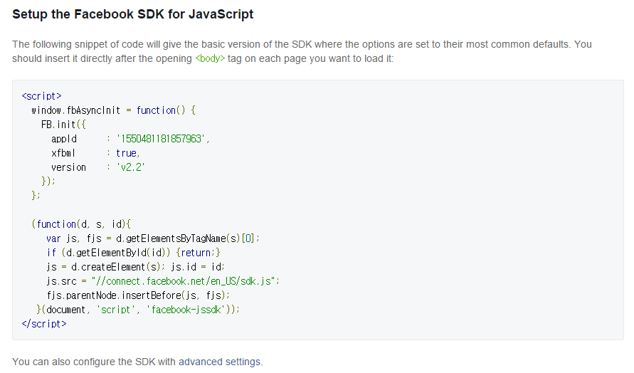

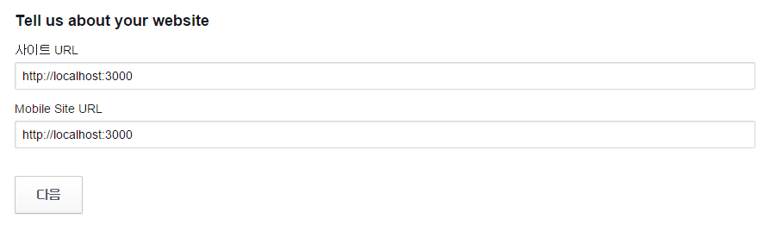

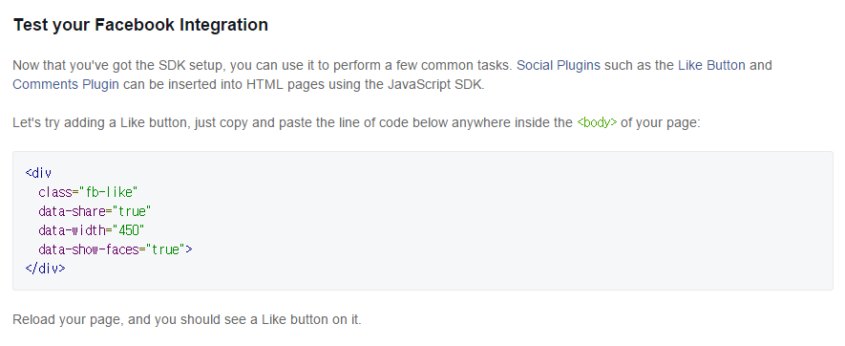

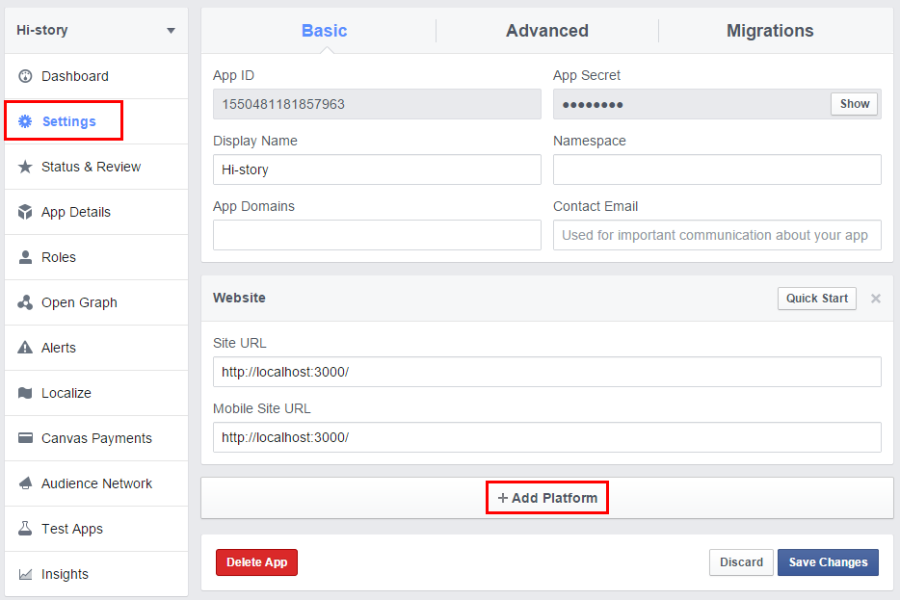



* Sign in at [https://dev.twitter.com](https://dev.twitter.com/) ( <https://apps.twitter.com/> )
* From the profile picture dropdown menu select **My Applications**
* Click **Create a new application**
* Enter your application name, website and description
* For **Callback URL**: [*http://127.0.0.1:3000*](http://127.0.0.1:3000/)
* Go to **Settings** tab
* Under *Application Type* select **Read and Write** access
* Check the box **Allow this application to be used to Sign in with Twitter**
* Click **Update this Twitter's applications settings**

